
Medium (3/5)

Uses learning platforms and digital knowledge tools to coordinate training, support onboarding, and track development progress.

Digital Maturity
Bio
Mia supports technician development by providing access to training, technical knowledge, and best practices. She helps reduce onboarding time, promotes knowledge sharing, and ensures teams can quickly become productive and self-sufficient when maintaining complex machinery.

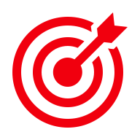
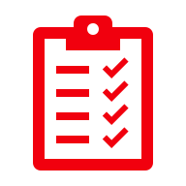
Goals
- Accelerate onboarding and workforce development
- Improve technician competence and confidence
- Reduce dependency on expert knowledge
- Standardize maintenance best practices
- Enable continuous learning and knowledge access
Key tasks
- Coordinate training
- Onboard technicians
- Maintain learning content
- Schedule training
- Track skill development
- Share best practices

Mia
Training Coordinator

"I need to ensure our technicians have the skills, knowledge, and confidence to maintain equipment safely and effectively while reducing dependence on a few experienced experts."


Pain points
- Knowledge is fragmented and difficult to access
- Heavy reliance on experienced technicians
- Training content is difficult to find
- Slow onboarding of new employees
- Training is disconnected from daily work
- Manuals are difficult to use in practice
- Low confidence with complex equipment
- Learning resources are not shopfloor-friendly



JTBD
Enable technicians to become productive faster.

Department
Learning & Development / Technical Training

Work environment
Training facilities, office environment, digital learning platforms

Needs
- Machine-specific training content
- Short videos and practical learning resources
- Step-by-step maintenance procedures
- Searchable technical knowledge base
- Training linked to equipment, parts, and error codes
- Troubleshooting guidance and best practices
- Structured onboarding programs
- Continuous learning on upgrades and innovations
- Simulations and safe practice environments
- Visibility into workforce capabilities and skill gaps

